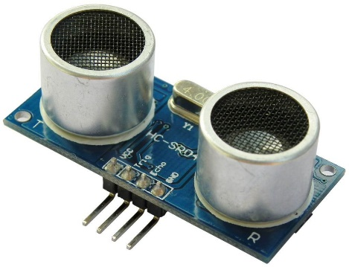

**ULTRASOUND**

|  |  |
| --- | --- |
| **PIN ON DEVICE** | **PIN ON ARDUINO/BREADBOARD** |
| Echo | 13 |
| Trigger | 12 |
| Vcc ( +ve ) | +ve rail |
| Gnd ( -ve ) | -ve rail |



**SERVO**

|  |  |
| --- | --- |
| **PIN ON DEVICE** | **PIN ON ARDUINO/BREADBOARD** |
| Signal | 10 |
| Vcc ( +ve ) | +ve rail |
| Gnd ( -ve ) | -ve rail |

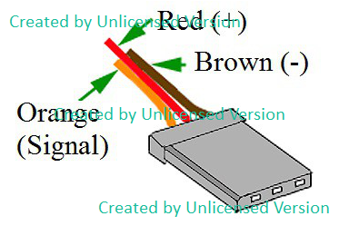

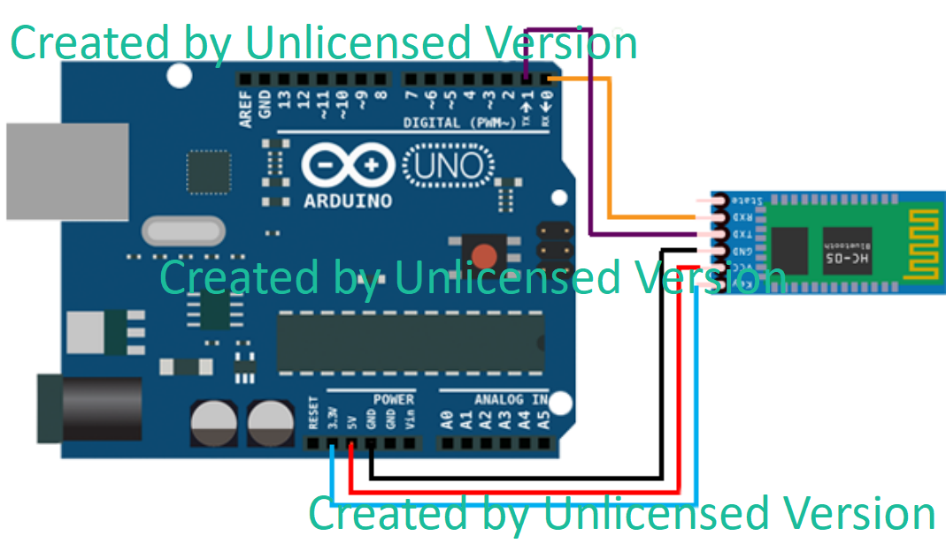

**BLUETOOTH**

|  |  |
| --- | --- |
| **PIN ON DEVICE** | **PIN ON ARDUINO/BREADBOARD** |
| Rx | 7 |
| Tx | 4 |
| Vcc | +ve rail |
| Gnd | -ve rail |

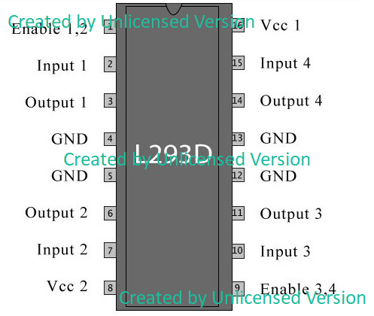

**L293D**

|  |  |
| --- | --- |
| **PIN ON DEVICE** | **PIN ON ARDUINO/BREADBOARD** |
| 4,5,12,13 (Gnd) | Gnd ( -ve rail ) |
| 8 ( Vcc 2 ) | +ve of battery2 ( 9V ) |
| 16 ( Vcc 1 ) | +ve rail( 5V) |
| 3 (OUTPUT 1) | Motor 1 (First wire) |
| 6 (OUTPUT 2) | Motor 1 (Second wire) |
| 14 (OUTPUT 4) | Motor 2 (First wire) |
| 11 (OUTPUT 3) | Motor 2 (Second wire) |
| 2 (INPUT 1) | 3 |
| 7 (INPUT 2) | 5 |
| 10 (INPUT 3) | 9 |
| 15 (INPUT 4) | 6 |
| Enable 1,2 | +ve rail(5V) |
| Enable 3,4 | +ve rail(5V) |

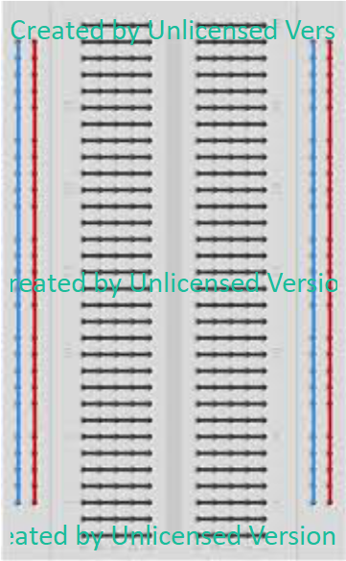

**5V pin on Arduino**

**-ve terminals of both batteries, Gnd pin of Arduino**

**Other Connections**

* Connect Battery 1 Positive(+ve) terminal to Vcc on Arduino
* Motor requires 9V to run, therefore a rail kept separately for it.